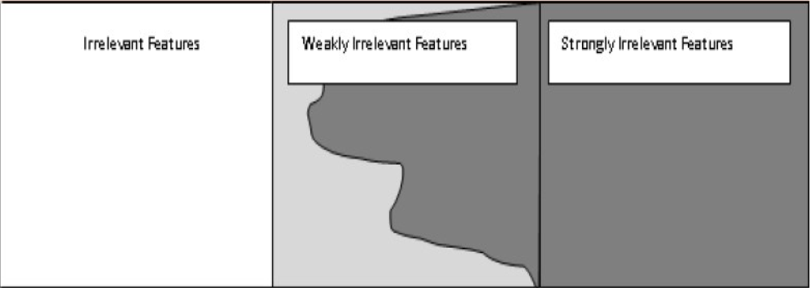

**Strongly Irrelevant Features**

**Weakly Irrelevant Features**

**Irrelevant Features**